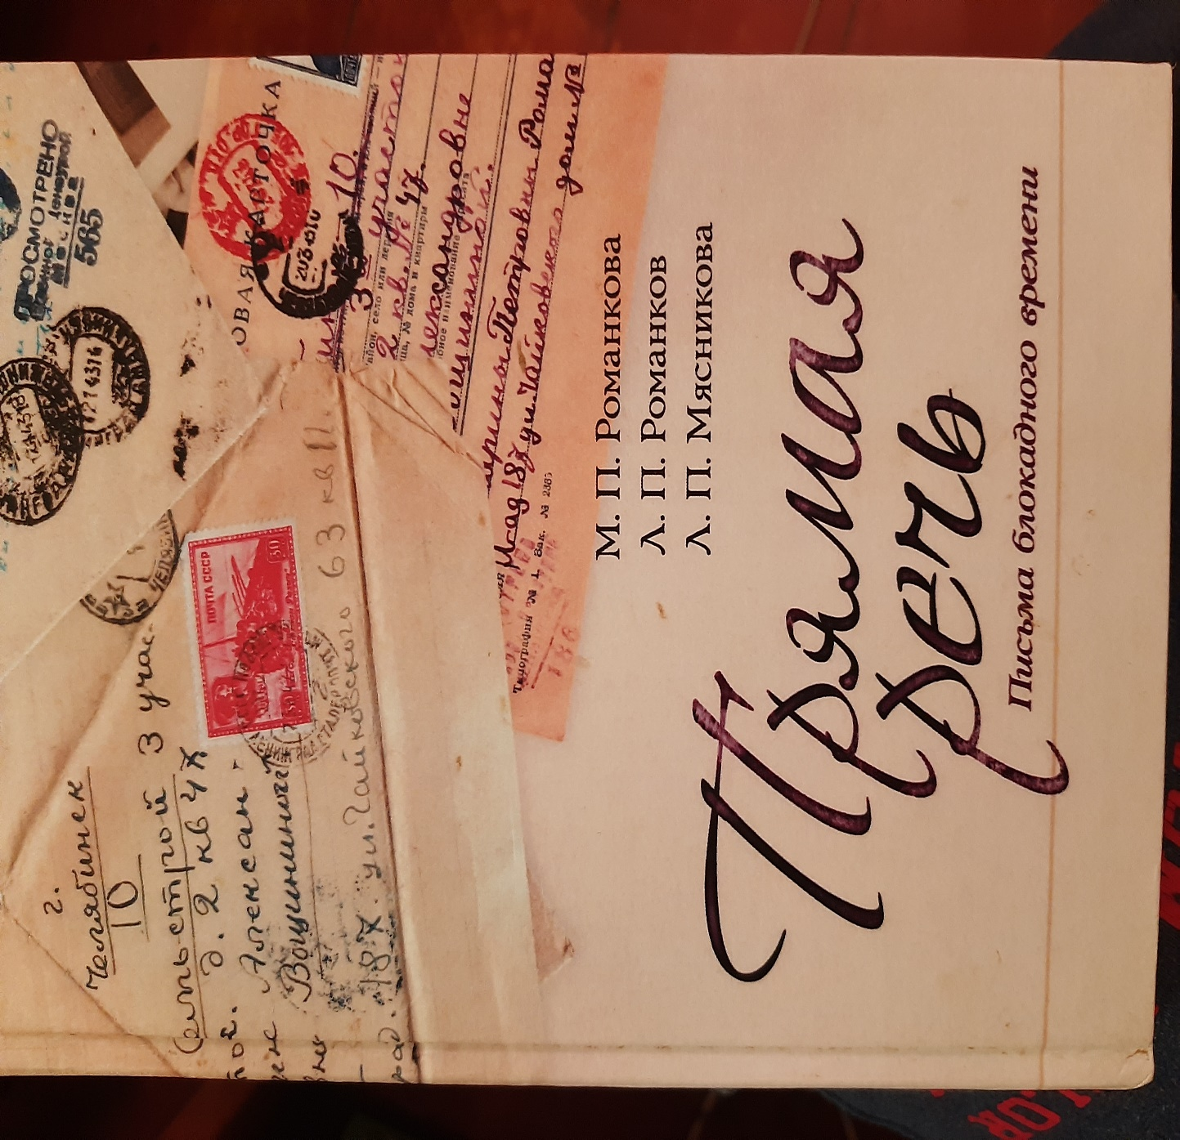

How much is left of the older generation? Have you thought about this? They have laid the foundation that we can use to enter tomorrow confidently. One of the former German language teachers at the Moscow State Technical University Irina Aleksandrovna Voshchinina died in 2014 at the age of 100 and left us an invaluable baggage of knowledge about people's lives during the Great Patriotic War. More than 70 letters were written to her by her relatives (the Davydenkovs) from besieged Leningrad. In 2019, they were published as part of family chronicles in the book “Direct Speech” by M. Romankova, L. Romankov, L. Myasnikova.
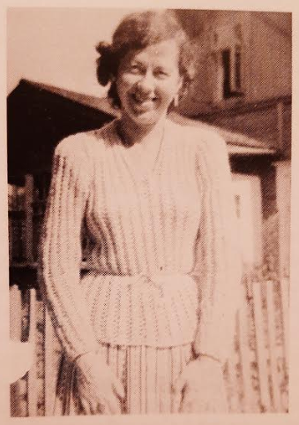
I.A. Voshchinina
By collecting and saving these letters — stories related to the blockade, even after death, she could teach students a very important lesson in survival — survival through generosity, kindness, and honor.
Irina Alexandrovna Voshchinina was born in 1913. She had a twin sister Veronica, who unfortunately died from Spanish flu when she was only seven years old. And in the same year, her father joined the army because the Civil war was going on.
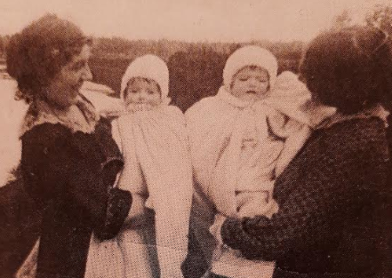
Vera Mikhailovna with twin sisters
After the war, her mother, Vera Mikhailovna Roth (nee Kondratyeva), did not have enough money, so Nikolai Nikolaevich and Lyubov Mikhailovna Davydenkov took Irina into the family and raised her together with their children, which gave Vera the opportunity to somehow arrange her new life. The senior family members called Irina “our daughter”, and the younger ones were her friends and kept this love until the end of days.
Irina was sent to study at the only German language school for girls in Leningrad, the so-called Annen Schule, in which, later,after the revolution, the Spartak movie theater was located.
There was also a German school for boys on Nevsky, the so-called Peterschule. They say that they studied Latin and Greek. Seniors, having completed the classical pre-revolutionary gymnasiums and who knew several languages, including Latin and Greek, attached great importance to the study of foreign languages. Irina, having finished school, was fluent in German, then she entered the Institute of Foreign Languages and subsequently taught German at the Higher Technical School. N.E.Bauman in Moscow. But it was still to come. At 19, she married 23-year-old engineer Alexei Ilyich Voshchinin, who idolized her, and she was in love with him and only dreamed, as she said, that divorces would be prohibited in the country. Alexey Ilyich Voshchinin graduated from the Leningrad Institute of Precision Mechanics and Optics, began to work, and then graduated from the Shipbuilding Institute in 1932 without interruption from production. Since then, his scientific and practical activities have become inextricably linked with the sectors of construction and road engineering. In 1941, when he was 34 years old while working at the Shipbuilding Institute, he protected his Ph.D. thesis.
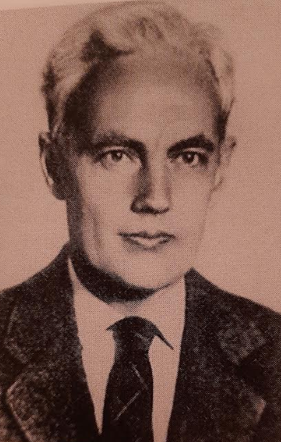
A.I. Voshchinin
When the Germans surrounded Leningrad, the city authorities began to evacuate those people who could strengthen the country's defense working in the rear, Alexey Ilyich was included in one of the first lists of specialists evacuated from Leningrad by plane-. At that time, Irina Alexandrovna was already working in the evacuation hospital. Irina recalled that Alex burst home late at night and said that there was an order to pack up and fly to Chelyabinsk urgently. Mothers were not allowed to be taken with. If they had not complied with the order. they would have been shot.
Therefore, when the Voshchinins left Leningrad in November 1941, they were followed by a stream of letters from the rest of the family: first of all, from “uncle” Nikolai Nikolaevich Davidenkov and from Marinochka (daughter of Lyudmila Nikolaevna and Pyotr Grigoryevich). ) The women in the house in Tchaikovskaya street were too busy with household chores and family survival problems to write often. Irina Alexandrovna carefully preserved all these precious papers, for which we are infinitely grateful.
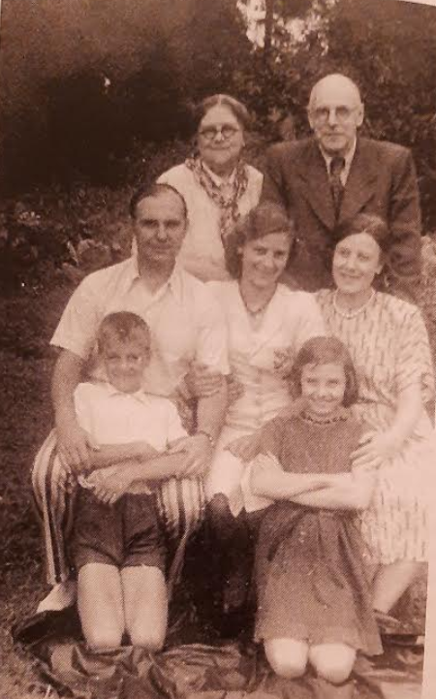
Top row: L.M. and N.N. Davidenkov
Second row: Peter Grigorevich, Marina and Lyudmila Nikolaevna Romankova
Down below: Lelka and Buska
The first letters from the besieged Leningrad went in December 1941.
By Gevorg Manucharyan, FS4-62
3.12.41
“Dear Irinochka!
When we received your postcard, we all calmed down, even the “academician Davidenkov” wept, not to mention everyone else. Kolya slept very badly, he was thinking about you. I am sending you this letter of opportunity; Uncle Serezha flies- where to& Nobody knows . Today Kolya and I have gone to buy bread, and we've been done out of 11 grams! We have no light. I want to tell you important news: Japan has declared war on America and England. It has already made two air attacks and a sea
one on the Hawaiian Islands.
Translated by Usman Turkaev, ICS8-44
L-d, 9.12.41
“Our dear and lovely girl!

…It was so sad and terrible to part with you, and the more time passes, the more we feel the separation and the severity of the step that you have had the heart to undertake . Nevertheless, we take comfort in knowing that you are more protected and better fed than we are. We continue to live our usual life; recently we have been shaken again, and even in our apartment house a lot of window panes have been blown out into the yard. We have managed the meals and are not starving. Your mother has finally moved to our place, she goes out only if she is on duty, and is in charge of lighting with us. It's been already five days since the blackout, and we have settled for an oil lamp. Slavusha is going to defend his doctoral dissertation while their institute is preparing to leave – for the destination known to you.

Your K.”
Translated by Turkaev Usman, IU8-44
...41
“Our dear, beloved girl!
...Thank you, dear, for taking care of us: probably you have spent exchange reserves on bread for us? We’ve got upset because of that, especially since your package, unfortunately, has not reached its destination: at such a time as now, food delivery mission is not accomplished!
...We go to sleep in comfortable and warm beds, and we all think about you, how you spend nights there if you are cold or don’t sleep. Are you at least fed? Here they say that everything is bad there in Ch. Queues torment us the most; poor Lina often does not sleep because of this. But in general, we are relatively fed, do not worry about us. Petya and I have friends — our former students, who from time to time help us a little. But we cannot forgive ourselves for not having thought much about the future.
Your auntie is still obsessed with our food problem and gets so tired that in the evening she falls off her feet and she has no time for correspondence. We sleep badly - although we go to bed early (at 9½, 10 p.m.), we wake up at 3-4 a.m. and then we can’t fall asleep until the morning, disturbed by worries and black thoughts. Lina has finally quitted her job and helps her aunt. Petya goes to Tech.(nological) in.(stitute) on foot, gives there 4 lectures a day and gets very tired. The most unfortunate thing is that we have to stay in the dark, I am writing this letter in the light of an oil lamp, and this is partly why it’s so bad. Your mother lives with us and goes to her place only on duty. She goes to H.(ouse) of S(centists) for lunch (daily)
We kiss you, our dear girl, a thousand times and hope to see you soon: things at the front seem to be going better. You will receive this letter already in 1942; Happy New Year and we wish you new peaceful happiness, without war.
Yours, K.”

Translated by Ramazan Salikhov, ICS4-62
17.12.42

“Dear Irushenka!
Now we are deprived of everything. There is no light, there is no water, the sewage system does not work, the radio works very rarely, and we take our sh-t in buckets to the cesspit. We were offered to go by car anywhere we wanted. We did not want to think about it yet, because everything was “fine”. But now we are giving it second thoughts. We are thinking about moving to Kazan with the Institute of Technology .We are taking much trouble in order that St. Petersburg State Technological Institute should let our daddy go there. But nothing is known yet. They do not let him go, because he is liable for military service, and we cannot leave him here alone. Kolya and I sent a telegram to Ufa, to his Institute, and stood in the line-up for bread (that’s the main thing). And to our great happiness, we got it then. They give 200 grams of it to us . After 125 grams it seems to be a great support. We’ve got scales, and we weigh everyone’s candy, bread and butter rations. To tell you the truth, at present we need to weigh only bread, since nothing else has been given out yet . They say that they will soon begin to distribute something else - that would be the greatest happiness. During this period my mommy is terribly exhausted, so is Uncle Slava.
We are very happy when we bake cakes usind the coffee grounds we have accumulated over the week and the remnants of potato flour. We also add some soda and salt and nothing else. There’s nothing else to put. But this seems to be an incredible bliss. We have forgotten about thick soup, and porridge, though babies sometimes have thin gruel, and I also get something from it. We have already forgotten about butter and fats, sugar, sweets, proteins, meat in general. Somehow we are still standing.
Unfortunately, we have not received your 2 kilograms of bread. The service that you, Irushenka, sent it with, must have eaten it . However, the letter has been dropped into the postbox .
Your Marina.''

Translated by Ilya Khmelnitsky, ICS 8-44

9.03.42
''Dear Irinochka!
This letter is very short because I ‘ve got the deficiency of vitamin A of my eyes and it is tiring to write, read, sew and do any petty work. Daddy has got sick. He has exudative pleurisy. Mom cupped him and made a warming compress for him. His highest body temperature was 39.5 C, and now it is 37.9. Still lower. Sorry, I cannot write anymore. My headache starts right away. I beseech you, do not grieve for us. We are still alive, though with difficulty. After all, we have lost pretty much weight . Do not be sad, my dear. And above all, be healthy and well-fed.
Yours Marina.''
7.04.42
''Sweet Irinochka!
Now according to your commandment, I help my mother and granny a lot with the housework, cleaning the room and cooking lunch and breakfast .I go with Kolya for bread and soymilk, which is prescribed for the children. It is very tasty. We have not visited to the Petushkovs for a long time. However, the third day, the whole house went. We had stayed for 2 hours, and got very tired and exhausted (we got scared, you know why). We are not going anywhere because dad is sick and mom is weak.
Yours Marina.''
Translated by Boris Bogunov, ICS7-23M
16.01.43
“My dear, Irinochka!
Great thanks to you and Lesha for your words of sympathy for my huge and irreparable grief. Your compassion is especially valuable to me. My mother’s death was a complete surprise for me. In Yuryevets, mom and Nyutochka finally adopted to new living conditions; they had to work hard in spring, summer and autumn to face the new winter without fear. The mother's body, which had been damaged by a life of hard work , failed when she got another illness, which could not have happened if everything had been normal. I have always dreamed of the time when we, I mean children, will give our parents a quiet, comfortable and joyful retierment" - carefree and well-fed. Lesha fully understands me, because he has lost his mother too... With this war, everything went upside down. Will we sum up the results together? I would like very much to meet you and look at our life from the new point of view created by the war, and to live in the old way, that is, in essence, a good one . How little we appreciated the absence of shelling, bombing, and starvation. Despite of its damaged appearence , our town is still proud and in quiet minutes makes us remember about its dear past. These memories are very warm, invigorate and give us hope for tomorrow. We will live, as you write, with this hope for a meeting and for the best, happiest times. I am now very concerned about the health of Linusha. She has a kind of chroniosepsis (remember her illness in Detskoye Selo , but it is a milder form now). We look forward to streptocide, but we haven’t got it yet. The kids have almost recovered. Marisha is at the cooker , Linochka has been staying in bed since the end of December.
I am with you in my thoughts.
I hug and kiss you tightly and gently
Always yours P.
Lots of kiss to Lesha very”
Translated by Veronika Kuznetsova ICS6-65

14.02.42
“Our dear daughter!
…We think that you will approve our decision not to go on this journey with the children. We fear frosts, and famine, and changing vehicles, and lice with typhus, and high prices – we have very little money, and at your place, as we know, the prices skyrocket and everything goes scarce. January was a hard month for us but we got through it, now it’s all better, and we hope that the curve has already passed its minimum. Besides, I’ve recently received the second academic ration which helps us a lot. All in all, we feel quite okay; Linusha has weakened the most, we take care of her and ask her to spend more time lying in bed. Slava has lost a lot of weight, he is going to the hospital at the House of Scientists, where he will spend 10 days and get some food. Natasha demonstrates great skills at getting food supplies and saving the family from starvation, but she has lost much weight as well. Aunty has lost so much weight and is unrecognizable, but her former plumpness supported her a lot. She takes care of the kitchen selflessly and bravely and cooks us lunch; after that she is so exhausted that she falls into bed she sleeps until evening, but suffers from insomnia at night.
…Let me describe you our typical day. We wake up at 8 or 9 am. Petya goes to heat the stove, your mum is still asleep, and Marina, too; then Marina goes to take the slops out and bring some clean water (from Chernyshevsky prospekt). After that the children have tea with white bread which is obtained for them by medical certificates. Then we – the adults (with Marina) – get to eat our morning breakfast. We have soup, bread and butter or often with oil ( we simply dip a slice into the bowl with it), drink coffee with sugar cubes on the side. This all gives us such an unspeakable pleasure we can hardly wait for while still in bed. Then the cooking of lunch begins; Vera goes to the clinic to get some soy milk for the kids, while Marina and I go to the bakery for bread. Usually, the queue isn’t that big and we manage to get back in ¼ - ½ of an hour. I make the purchase with Marina assisting me. We go back hand in hand holding the bag with bread between us – that is done to protect in from possible attacks (sometimes bread and ration cards are snatched right in the bakery , we must always be alert; the wrong ration cards are often cut off because of malpractice; they usually weigh us 15-20 grams less.) There used to be problems with bread, and queues appeared, people were lining up all night; we once had to queue from noon to 11 pm and still got nothing. The reason for it was the frost that left factories without water. But now everything is fine. Bread is good, light, without additive surrogates and it’s very delicious. All in all, we now think that there’s nothing more delicious than bread, especially with butter or oil.
At 12 pm we drink a cup of hot cacao or soy milk. By 2 pm we all start drooling as our appetite comes and at 2 pm we have lunch: soup, thin gruel, coffee, everything is extremely tasty. At 5 pm children drink coffee with white bread. At 7 pm – children’s evening dinner, at 7 ½ or 8 – our dinner: it’s soup or gruel, drench, coffee. Everything is absolutely delicious; our whole day is generally waiting for a new meal. We’ve bought scales, and Marina and I are main “bread-dividers”: we weigh out all the bread to the eaters. At 9 p.m. we go to bed, but we wake up at 2-3-4 am and suffer from insomnia till morning. It’s hard to work in the evening with an oil lamp, especially since we’ve got only two of them in the flat; but Marina still manages to read aloud “The Captain’s Daughter” or something else for an hour. It’s always warm in our place, and it helps us a lot.
So, this is the plan of our day; as you see, we don’t live bad, and although we starve, but no more or less than others. Your mother looks like a girl, and your aunt, too. But she learnt a new pleasure – having meals when hungry. All of our dreams are also about food. Since you left the bread ration has been increased 3 times, and now its size is satisfactory. Since February we ‘ve got a hope not to die from starvation, and our mood has got much better. We don’t think that you and Lyosha would have survived till now, like your aunt Dunya, like three old ladies next door , like many others.
Your mum still goes to get lunches to the House of Scientists and makes us worry about her until she comes back, because all kind of misfortunes happen to her all the time: once her money was stolen, or she was pushed when queueing and so on.
It’s a miracle that there were no air raids this winter, I ‘ve started to take off my clothes at night, and we even turn our radio on to sleep better. Petushkov has passed away, and now there’s an office in his flat. We are extremely disappointed because of the neighbours who pour their slops everywhere. In the streets, and under their windows, and onto the pavements, and in our yard with a through passage which is now disgusting to walk through. To sum, in these hungry times, the true human nature comes out and it’s now obvious who is a decent person and who is not.
We are no longer able to get out of the city; the conditions of leaving are horrible, the frost, we’ll have to travel on trucks across Ladoga lake, gunning, crowding, starving during the journey – this all is completely impossible to do with the children. While food supplies are still seeping into Leningrad, we exist and we would like our existence to be stable, we lack a bit of groats to survive with an academic ration. But how long it will last – nobody can tell.
You wouldn’t recognize our city now; it has changed drastically. Now there are so many people in the streets, completely out of nowhere. These are the people who used to take the tram before. All the time there are sleds behind them with long wrapped into white or black cloth objects on them; they are dragged by indifferent people, who sometimes stop to smoke. In ½ an hour we can see 15-20 of these sleds. There are sounds of artillery shooting in the distance. All the shops, except for grocery stores, are closed down: in the latter there are queues outside with people shouting , swearing, making nose. Opposite the bakeries there are small “exchange offices” where people mainly swap bread for tobacco and cigarettes. All people have dirty faces because they don’t wash . On Chernyshevsky prospect there’s a never-ending movement of sleds with buckets, people going for water to the Neva river as in a village even the rocker arms have appeared. A rare automobile passes by, leaving behind the smell of fir- needles (the new fuel). All people carry bags mainly with bread, bread is the most important food for us now: we have just learnt that there’s nothing more delicious than bread with oil or even without it.
We try to teach your mother how to work and sometimes we even succeed. Marusya (*their housekeeper employed before the war ) is our biggest trouble, she grabs and eats everything that is left or stored ; no persuasion helps, and everything has to be locked away.
Well, we kiss you tightly and tenderly, love you very much, think of you all the time, hope to meet – sooner or later. Your aunt kisses you and doesn’t write letters because she gets exhausted, but her souls is with you. All the rest kiss you and Lyosha. Especially Linusha.
Send us your address.
Your K.”
Translated by Daria Erchenko Daria, ICS6-65
All letters are taken from the book of M.P. Romankova, L.P. Romankov, L.P. Myasnikova "Direct Speech. Letters of Blockade Time", St. Petersburg: publishing house "Helikon Plus", 2019. - 148 pp. 148 pp.

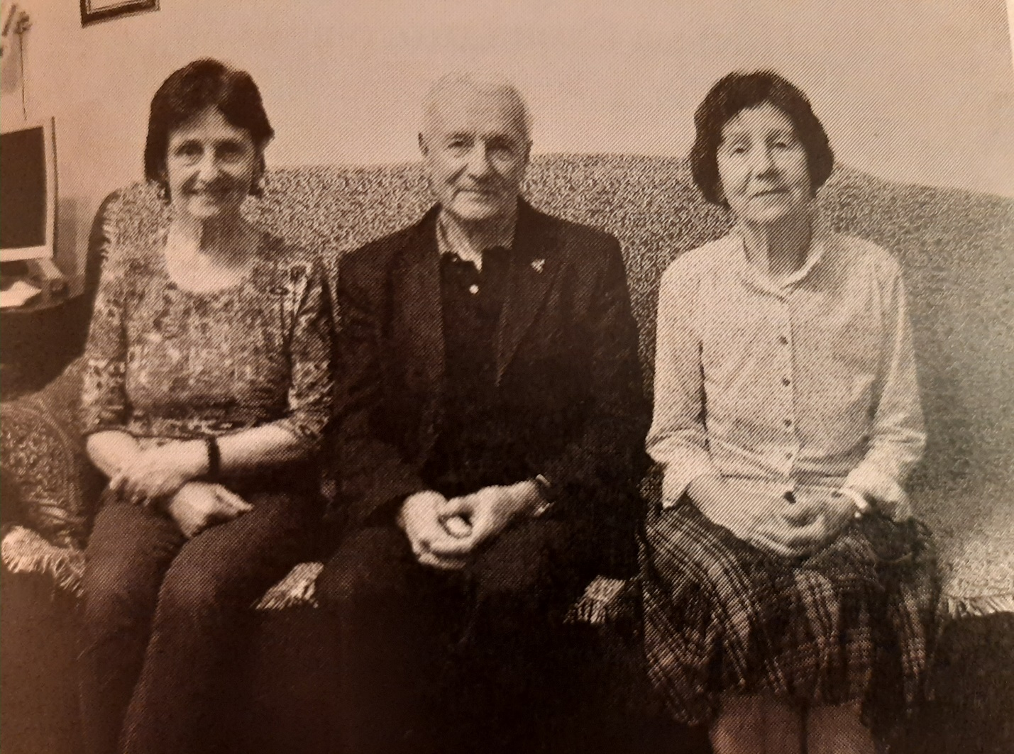
L.P. Myasnikova, M.P. Romankova, L.P. Romankov,

